**Programming Challenge 1 – February 28, 2019 – Due on February 28 by 10:00pm**

**Objective:**  **name constant, if / else if and trailing else statements**

|  |
| --- |
| **Important instructions:**   * *All programs must include comments at the top of your program: your name,* the class name (CSIT 575)*, program name and* ***the program description (purpose of the program).*** * *Copy and paste your* ***program code*** *and* ***output*** *in Part B of each program. Note: Use snipping tool to snip the output.* * *Once it is done, save and submit this word file via Canvas.* |

1. **Dollargame.cpp (25 points) –**

Create a change-counting game that asks the user to enter what coins to use to make exactly one dollar. The program should ask the user to enter the number of pennies, nickels, dimes, and quarters. If the total value of the coins entered is equal to one dollar, the program should congratulate the user for winning the game. Otherwise, the program should display a message indicating whether the amount entered was more or less than one dollar.

**Sample run 1**

The goal of this game is to enter a combination of quarters,

dimes, nickels, and pennies that add up to exactly one dollar.

How many quarters should I use? 2

How many dimes should I use? 2

How many nickels should I use? 4

How many pennies should I use? 5

Your coins total $0.95. That is less than a dollar.

**Sample run 2**

The goal of this game is to enter a combination of quarters,

dimes, nickels, and pennies that add up to exactly one dollar.

How many quarters should I use? 4

How many dimes should I use? 1

How many nickels should I use? 3

How many pennies should I use? 1

Your coins total $1.26. That is more than a dollar.

**Sample run 3**

The goal of this game is to enter a combination of quarters,

dimes, nickels, and pennies that add up to exactly one dollar.

How many quarters should I use? 3

How many dimes should I use? 1

How many nickels should I use? 2

How many pennies should I use? 5

Congratulations. Your coins total exactly a dollar.

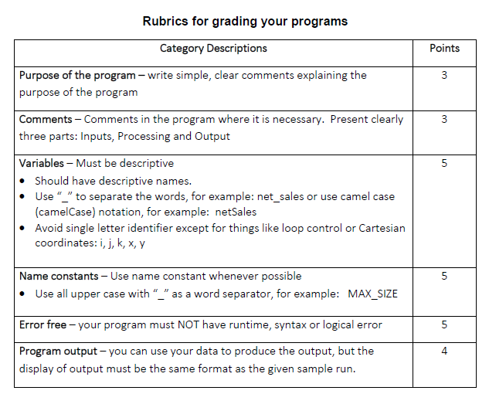

**Part B: Copy and paste your program (source) code and the outputs after this line.**

++++++++++++++++++++++++++++++++++++++++++++++++++++++++++++++++++++